Zoom Webinar Series by Diversity, Equity, Inclusion and Respect (DEIR) and by Women Chemists Committees
Tuesday, January 25, 2022 4-5pm Pacific Time
Living in a materials world:
designing organic semiconductors for advanced applications.

Speaker: Malika Jeffries-EL, PhD
Associate Dean of the Graduate School in Arts and Sciences
Boston University
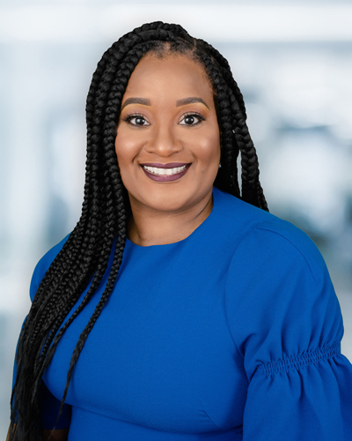
Most people own numerous electronic devices, resulting in an increased demand on the semiconducting materials that drive this technology, and the energy needed to power them. Accordingly, there has been a large amount of interest in the development of organic semiconductors, as many of the inorganic materials used in these devices are in limited supply. Organic semiconductors are either polymers or small molecules that feature and extended pi-conjugation. These materials possess many exceptional electronic, optical, and thermal properties and thus are well suited for applications, such as transistors, solar cells and light emitting diodes. In this talk, Dr. Jeffries-EL will discuss science, diversity, equity, and inclusion all woven within the context of her personal experiences.
All are welcome! Register in advance for this webinar:

Webinar registration

After registering, you will receive a confirmation email containing information about joining the webinar. Please contact tonnsj@plu.edu for more info.

