Living in a materials world: designing organic semiconductors for advanced applications.

Dr. Malika Jeffries-EL
Department of Chemistry and Division of Materials Science, Boston University
E-mail: malikaj@bu.edu
The past two decades has seen a dramatic increase in the number of consumer electronics in use. Previously, most households had a landline phone, one or two televisions and the occasional desktop computer. These days most people own numerous electronic devices, resulting in an increased demand on the semiconducting materials that drive this technology, in addition to the energy needed to power them. Accordingly, there has been a large amount of interest in the development of organic semiconductors, as many of the inorganic materials used in these devices are in limited supply. Organic semiconductors are either polymers or small molecules that feature and extended pi-conjugation. These materials possess many exceptional electronic, optical, and thermal properties and thus are well suited for applications, such as transistors, solar cells and light emitting diodes. Unfortunately, there are several issues that must be addressed before real-life products can be developed. Our group focuses on the design and synthesis of new organic semiconductors based on low cost and/or easily prepared starting materials. Since the properties of organic semiconductors can be readily modified through chemical synthesis, we have turned our attention towards the design and synthesis of novel aromatic building blocks. Our system of choice, benzobisazoles has many exceptional electronic, optical and thermal properties making them suitable for diverse range of organic semiconducting applications. Our group developed several new materials based on benzobisoxazoles including wide band gap materials for use in organic light-emitting diodes and narrow band gap materials for use in photovoltaic cells. We have also developed a versatile synthesis of benzodifuran, the oxygen analog of the popular electron rich building block benzodithiophene and have developing narrow band gap conjugated polymers based on it. Concurrently, we are also making molecular species based on this building block. Our work on the synthesis and properties and utility of these materials will be presented.

Although African Americans make up approximately 13% of the US population, they are severely underrepresented in advanced degrees awarded in STEM disciplines and within the ranks of the faculty at research institutions. Despite the overwhelming statistics, Dr. Jeffries-EL pursued and completed a doctorate degree in chemistry, obtained and academic job, and then tenure in promotion in due course. She was born in Brooklyn, NY where she lived in public housing and attended public school. Although her situation was less than ideal, she always had a passion for science that her parents encouraged her to pursue. In this talk, Dr. Jeffries-EL will discuss science, diversity, equity, and inclusion all woven within the context of her personal experiences.
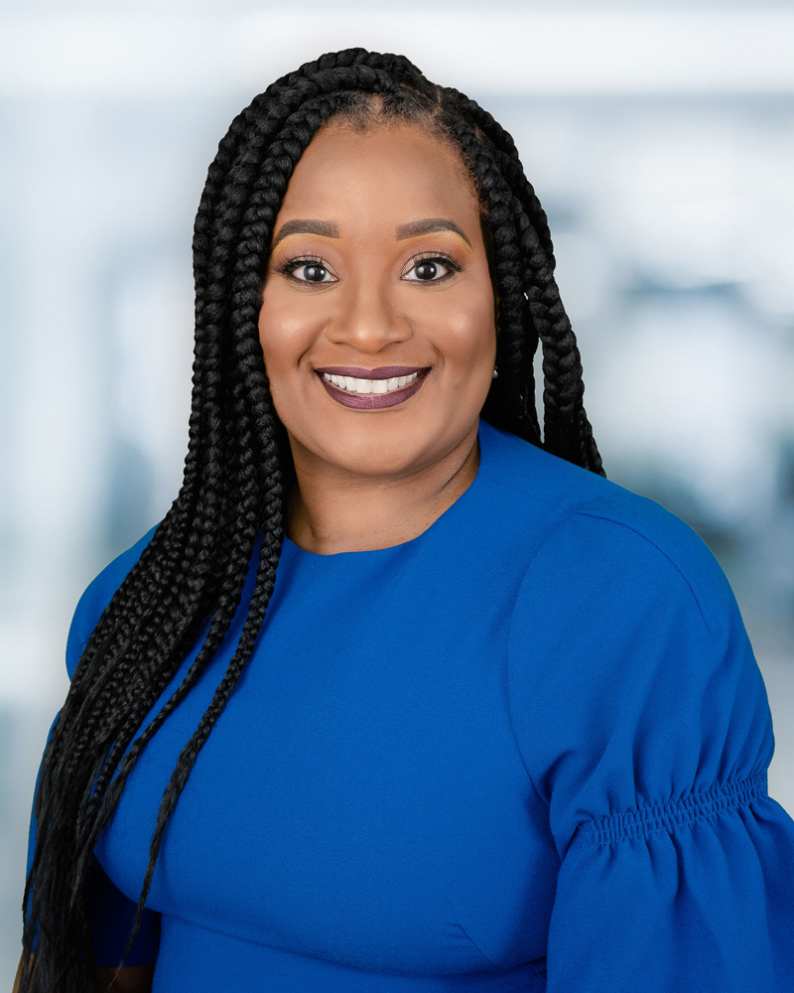
Malika Jeffries-EL received BA degrees in Chemistry and Africana Studies at Wellesley College and M. Phil and Ph.D. degrees in chemistry from The George Washington University. After spending one year at Smith College as a Mendenhall Fellow she worked as a post-doctoral researcher under the direction of Professor Richard D. McCullough at Carnegie Mellon University. In 2005, she joined the faculty in the Chemistry Department at Iowa State University and was promoted to associate professor with tenure in 2012. She was a Martin Luther King Jr. Visiting Professor in the chemistry department of the Massachusetts Institute of Technology in 2015. She joined the Department of Chemistry and Division of Materials Science at Boston University in 2016. Since July 2020 she has served as the Associate Dean of the Graduate School in Arts and Sciences.
Professor Jeffries-EL's research focuses on the development of organic semiconductors–materials that combine the processing properties of polymers with the electronic properties of semiconductors. She has authored over 40 publications, received over 4000 citations, and given over 160 lectures domestically and abroad. She has won numerous awards including the 3M Non-Tenured Faculty Award (2008), the Lloyd Ferguson Award from the National Organization of Black Chemist and Chemical Engineers (NOBCChE) (2009), NSF CAREER award (2009), the ACS-Women Chemist Committee Rising Star award (2012) the Iota Sigma Pi Agnes Fay Morgan Award (2013), ACS Fellow (2018) and the Percy L. Julian Award (NOBCChE) (2021). She is currently an Associate Editor for the Journal of Materials Chemistry C. She has also served on the editorial advisory boards for Macromolecules and Chemical and Engineering News. Professor EL, is also a staunch advocate for diversity and dedicated volunteer that has served in several activities within the American Chemical Society including the advisory board for the Women Chemist of Color Initiative and the Women Chemist Committee. She also serves the community through her work with Alpha Kappa Alpha Sorority, Incorporated (AKA). Dr. Jeffries-EL is a native of Brooklyn, New York.

